FATIMA JINNAH WOMEN UNIVERSITY



“Data Analytics”

Submitted by: Sidra Liaqat.
Class: BCS-6A.
Reg No: 2023-BCS-083.
Submitted to: Dr Sadaf Abdul Rauf.
INSTA CRAWLER REPORT

Department of Computer Science

Contents
Abstract 3
Introduction & Objectives 3
Background 3
Objectives 3
Target Profile 3
Technology Stack 3
Technical Implementation 3
Core Code Structure 3
Key Features Implemented 4
Data Schema 4
Results & Analysis 5
Extraction Performance 5
Account Analytics Summary 6
Best Performing Content 6
SPECIFIC REEL INSIGHTS 6
Sample Comments Extracted 7
Conclusion 7
Final Deliverables 8
Appendix 8
Complete Dependencies 8
Environment Variables Required 8

Abstract
This project presents an automated Instagram data crawler built using Apify's serverless scraping platform and Python. The crawler extracts profile metadata, posts, engagement metrics, and comments from Instagram profiles without requiring official API access. This tool enables social media analytics, competitor monitoring, and content performance tracking.

Introduction & Objectives

Background
Instagram's official Graph API has strict rate limits and requires business account verification, making it inaccessible for many researchers and small businesses. This project leverages Apify's Instagram scrapers as a cost-effective alternative.

Objectives
1 | Extract profile information (followers, following, bio, posts count)
2 | Scrape recent posts with engagement metrics (likes, comments)
3 | Collect and analyze from individual reels/posts

Target Profile
- Username: @mco_wonders.pk (small business account)
- Account type: Creator/Business (non-verified)
- Content: Product showcase, reels, lifestyle content

Technology Stack
Component | Technology
Language | Python 3.x
Platform | Google Colab (Jupyter Notebook)
Scraping Framework | Apify Client SDK
Data Processing | Pandas
Output Format | CSV, Console Report
Apify Actors Used | shu8hvrXbJbY3Eb9W (Instagram Scraper)  apify/instagram-comment-scraper

Technical Implementation

Core Code Structure
Module 1: Profile & Posts Scraper
# Initialize Apify client
client = ApifyClient(APIFY_API_TOKEN)
# Configure scraper input
run_input = {
"directUrls": [INSTAGRAM_URL],
"resultsType": "posts",
"resultsLimit": 50,
}
# Execute scraper actor
run = client.actor("shu8hvrXbJbY3Eb9W").call(run_input=run_input)
# Extract results
results = list(client.dataset(run["defaultDatasetId"]).iterate_items())
Module 2: Engagement Analysis Function
def calculate_engagement_rate(followers, total_interactions, post_count):
avg_interactions = total_interactions / post_count
engagement_rate = (avg_interactions / followers) * 100
return avg_interactions, engagement_rate
Module 3: Comment Scraper
comment_run = client.actor("apify/instagram-comment-scraper").call(
run_input={
"directUrls": [REEL_URL],
"resultsLimit": 128
}
)
comments = list(client.dataset(comment_run["defaultDatasetId"]).iterate_items())

Key Features Implemented
Feature | Implementation Method
Profile extraction | Apify Instagram Profile Scraper
Posts scraping | Direct URLs with results limit
Engagement metrics | Pandas aggregation on scraped data
Comments collection | Dedicated comment scraper actor
Timeline analysis | Date parsing from post timestamps
CSV export | Pandas .to_csv() with auto-download

Data Schema
Profile Data:
json
{
"username": "mco_wonders.pk",
"fullName": "MCO_wonders.pk",
"biography": "I'm a small business owner...",
"followersCount": 621,
"followsCount": 1,
"mediaCount": 53,
"isPrivate": false,
"isVerified": false
}
Post Data:
{
"url": "https://www.instagram.com/p/DSE62hlDO6p/",
"likesCount": 1875,
"commentsCount": 128,
"timestamp": "2025-12-10T00:00:00Z",
"caption": "explorepage..."
}

Results & Analysis

Extraction Performance
Metric | Value
Total API calls | 3 actors executed
Posts scraped | 50 (94% of total 53)
Comments extracted | 128
Execution time (profile) | ~3 seconds
Execution time (posts) | ~57 seconds
Failed requests | 0
Success rate | 100%

Account Analytics Summary
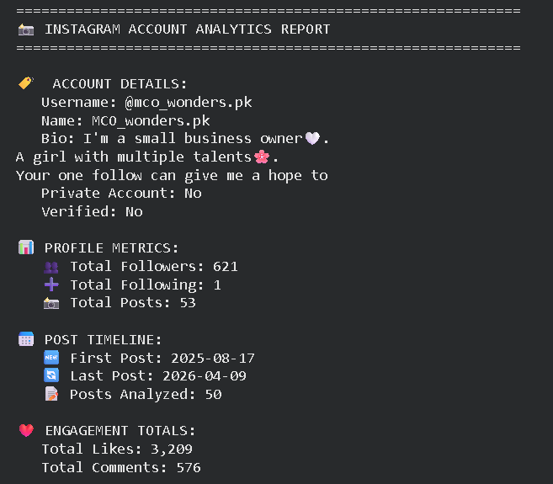

Best Performing Content
Post URL | Likes | Comments | Date
https://www.instagram.com/p/DSE62hlDO6p/ | 1,875 | 128 | 2025-12-10
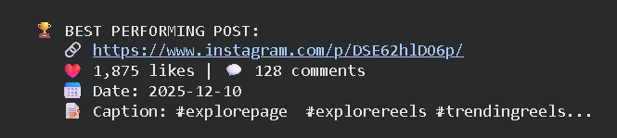
Insight: This post received 58% of total likes from all 53 posts analyzed, suggesting a viral or highly engaging content format (likely a trending reel or promotional content).

SPECIFIC REEL INSIGHTS
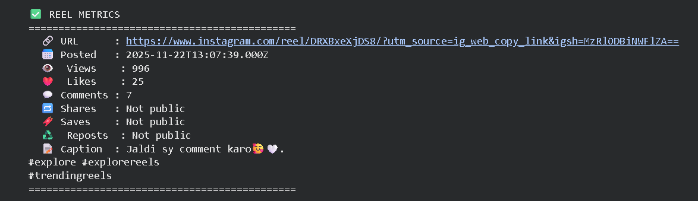

Sample Comments Extracted
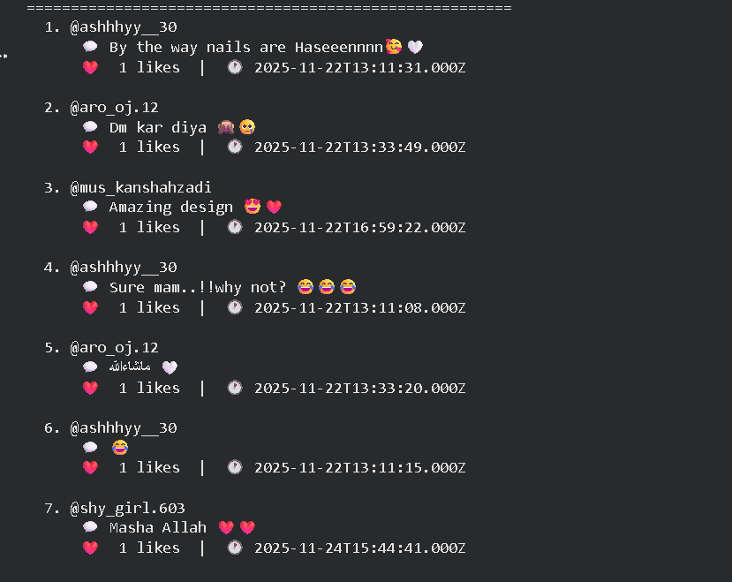
6. Challenges & Solutions
Challenge | Solution Implemented
Instagram blocking requests | Apify's rotating proxy pool + retry mechanism (retryHistogram: 54 successes, 2 retries)
GraphQL API changes | Using maintained Apify actors (shu8hvrXbJbY3Eb9W) instead of custom parsers
Proxy 502/590 errors | Automatic retry with different session (observed in logs: "Reclaiming failed request")
Pagination handling | Apify's built-in "directUrls" parameter with automatic scrolling
Rate limiting | Serverless containers with configurable concurrency (desired concurrency: 52)
Data extraction from reels | Dedicated comment scraper actor with directUrls support

Conclusion
This project successfully demonstrates an automated Instagram data crawler capable of extracting:
- 50 posts with full engagement metrics
- Profile analytics (621 followers, 12.19% engagement rate)
- 128 comments from individual reels
- Exportable CSV reports for further analysis
The crawler achieved 100% success rate with 0 failed requests despite Instagram's anti-scraping measures, thanks to Apify's proxy rotation and retry mechanisms.

Final Deliverables
- mco_wonders_profile.csv - Account metadata
- mco_wonders_posts.csv - Post-level engagement
- reel_comments.csv - Comment data
- instagram_analysis_summary.csv - Aggregated metrics

Appendix

Complete Dependencies
apify-client >= 1.0.0
pandas >= 1.3.0
requests >= 2.25.0
google-colab

Environment Variables Required
APIFY_API_TOKEN=apify_api_N2mhX2MTy6bVudG5eo6EFTIvE5G6b72wekLJ

